|  |
| --- |
| Photo displaying partial image of two pie charts on a canvas-textured page |
| Handwritten Digit Classification  Understand Meaning in Text |
| |  |  |  | | --- | --- | --- | | Muhammad Ibrahim (01-131172-039) | 11/18/19 | Visual Programming | |

Handwritten Digit Classification

Conversion of text, handwritten or otherwise into machine encoded form is called text recognition.

The central objective of this project is to learn about machine learning and how we can use different

Tools and Technologies:

Visual Studio 2019.

Machine Learning .NET Libraries and Functionalities.

Language C#

STEPS:

1. Identify Your problem.
2. Gather your data.
3. Split your data (30% testing and 70% to train model)
4. Transform your data (ML only works on float vectors) through one hot encoding.
5. Train your model (use algorithms- different for different scenarios) automatic ml chooses algorithm automatically according to dataset.
6. Evaluate your model. Check the 30% of the dataset for testing purposes, measure accuracy.
7. Deploy our model.

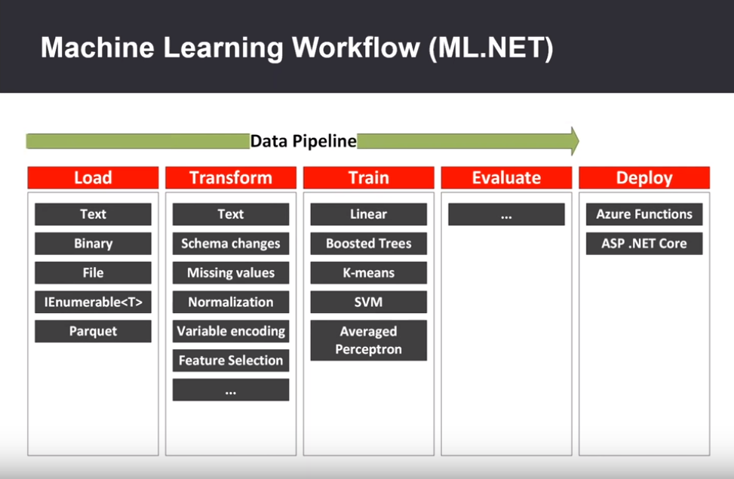

Workflow of Machine Learning.

How the Program will work with different stages.